**Flute**

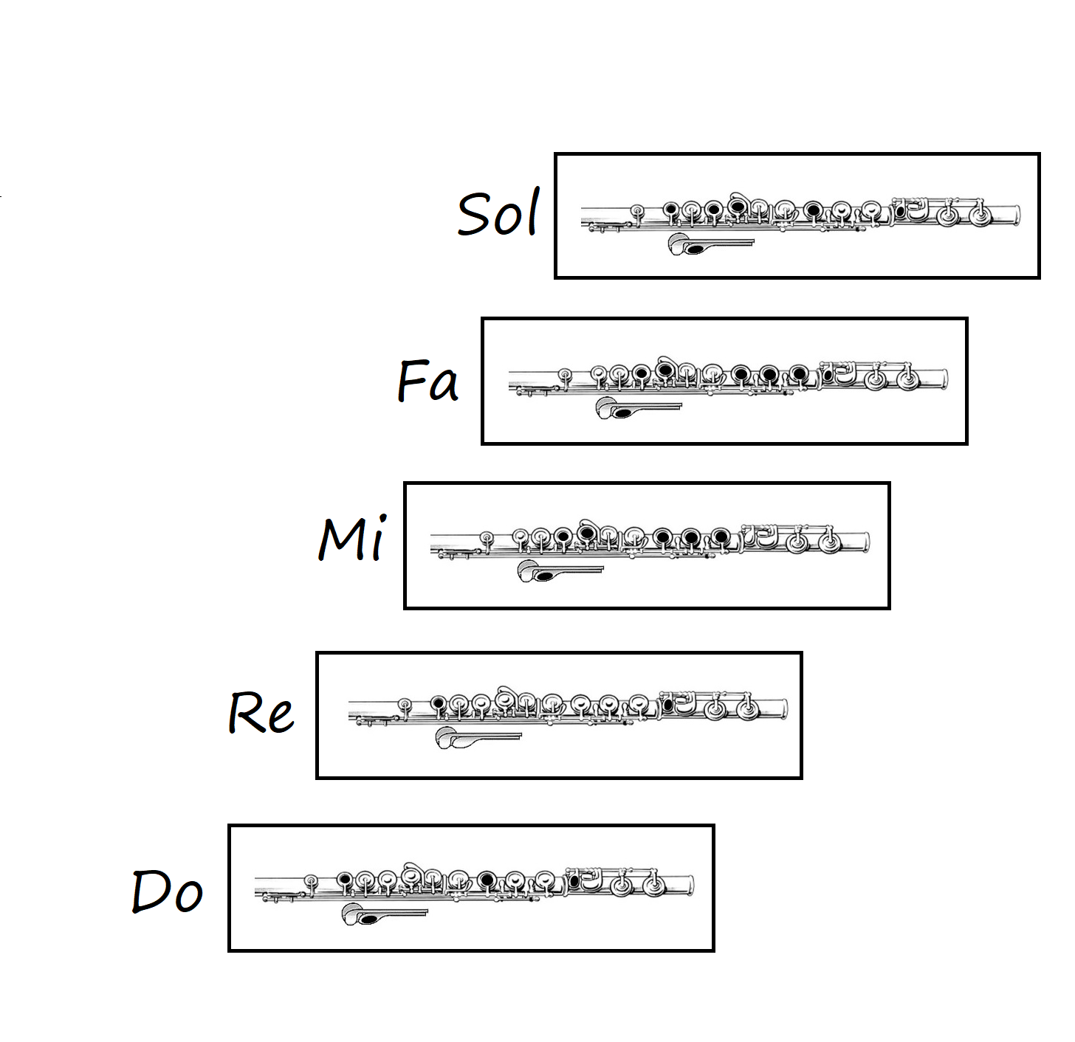

**Clarinet**

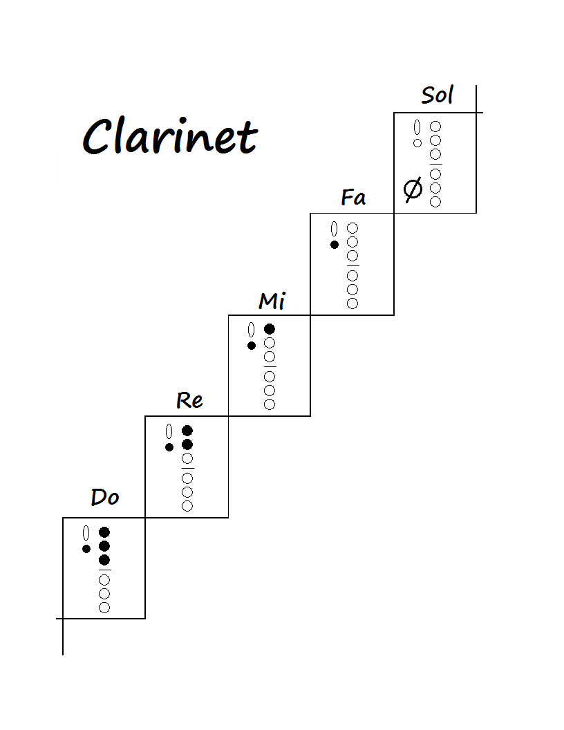

**Electric Bass**

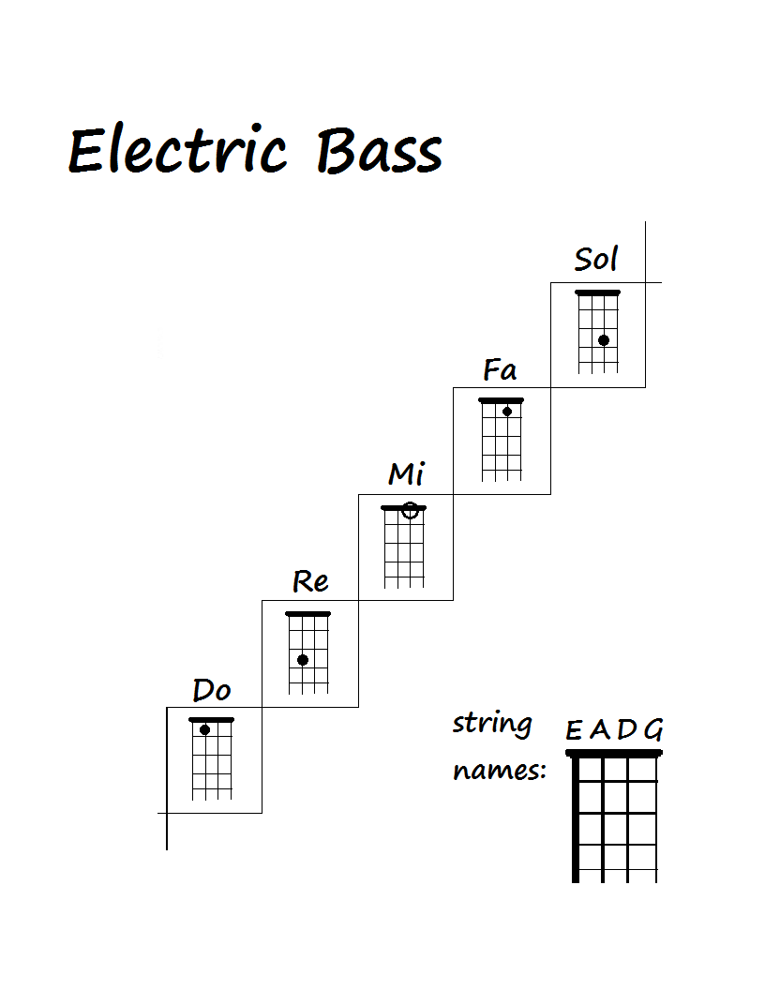

**Trumpet**

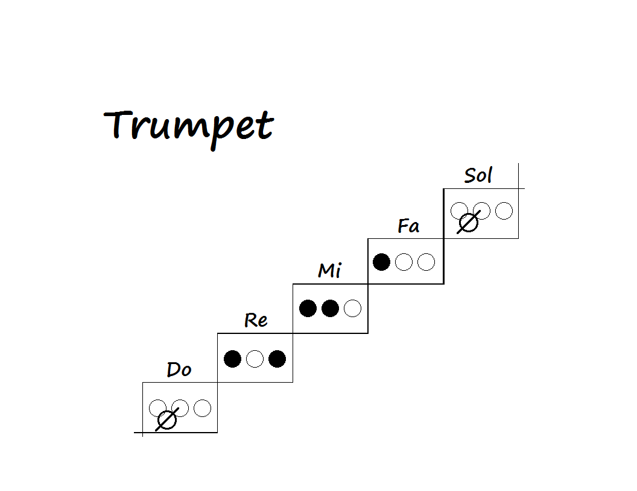

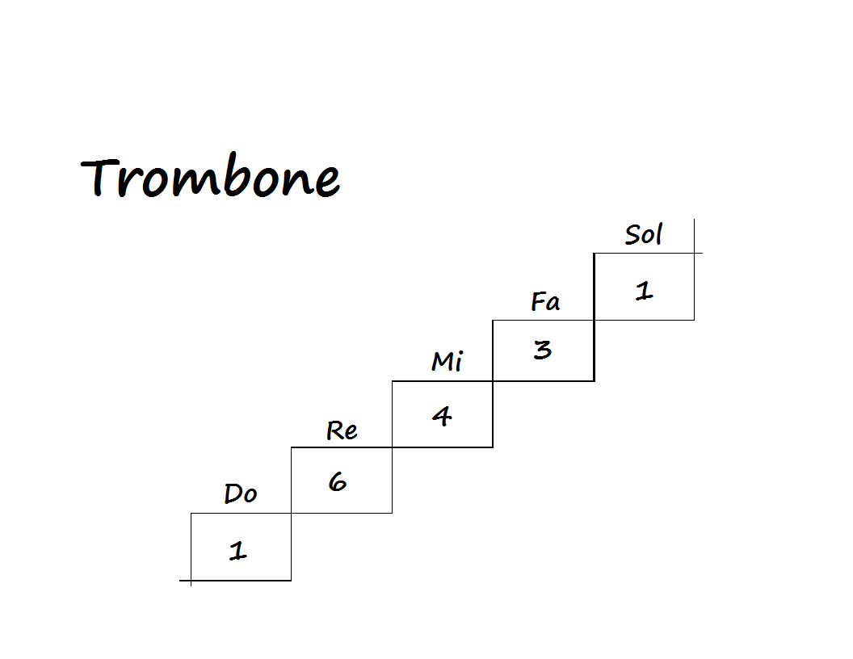**Trombone**

**The bigger the number, the further you extend your slide:**

|  |  |
| --- | --- |
| 1st Position |  |
| 3rd Position |  |
| 4th Position |  |
| 6th Position |  |

**Euphonium**

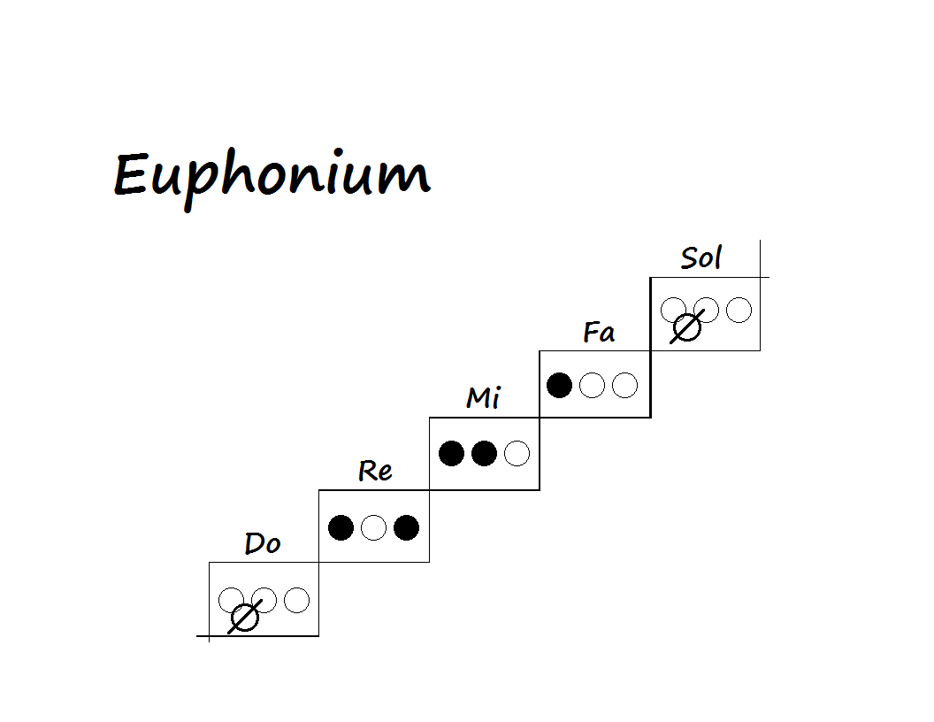

**Xylophone**

