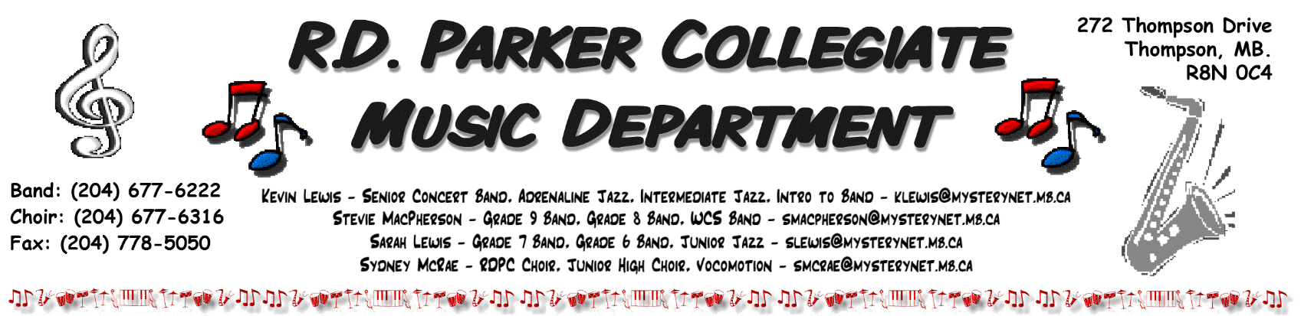

R.D. Parker Music Department Dates 2023/2024

September 27th, 2023 Thompson Music Parents’ Association AGM
R.D. Parker Band Room – 7:00pm

November 3rd – 5th, 2023 NorMan Jazz Festival
The Pas, MB

November 11th, 2023 Remembrance Day
C.A. Nesbitt Arena

December 13th, 2023 Winter Band Concert
Letkemann Theatre – 7:00pm

December 14th, 2023 Winter Choral & Jazz Concert
Letkemann Theatre – 7:00pm

TBD – February 2024 Grade 8/9 Band Trip – Optimist Music Festival
Winnipeg, MB

March 8th – 10th, 2024 Parkland/NorMan Honour Band Festival
Dauphin, MB

March 12th, 2024 the Underground Spring Swing Thing
RDPC Cafeteria – 7:00pm

March 14th - 17th, 2024 Brandon Jazz Festival Trip
Brandon, MB

April 24th, 2024 Spring Band & Choir Concert (Grades 7 – 12)
Letkemann Theatre – 7:00pm

May, 2024 Senior Tour 2024
Minneapolis, MN

June 4th, 2024 39th Annual Cabaret
Letkemann Theatre – 7:00pm

June 11th, 2024 Year End Junior Concert
Letkemann Theatre – 7:00pm

June 27th, 2024? R.D.P.C. Graduation Ceremony
C.A. Nesbitt Arena – 7:00pm

